

Mentor Training Manual

This document was developed under CMS Contract #HHSM-500-2013-NW005C. The contents of this document do not necessarily reflect CMS policy.

An Overview of the Peer Up! Program
Peer Up! is a peer mentoring program that pairs dialysis patients together to increase individual self-care behaviors. The program, designed for dialysis facilities, was developed by the Mid-Atlantic Renal Coalition, FHI 360, and UVA Lynchburg Dialysis, with funding from the Centers for Medicare & Medicaid Services. In a pilot study, Peer Up! was shown to increase knowledge, self-efficacy, perceived social support, and dialysis social support as well as decrease missed treatments in mentees. Mentors also benefitted with increased knowledge, dialysis social support, and self-management.

Facility staff pair dialysis patients together to meet one-on-one to share information and support. Pairs consist of a mentor and mentee. A mentor is usually someone that has more experience with dialysis who can help someone with less experience learn and adjust to life with dialysis.

Who This Training Manual Is For
This Peer Up! training manual is designed for facility staff responsible for running the Peer Up! program, such as social workers or nurse educators, to train prospective mentors so they can function effectively and confidently. The training is designed to be interactive, engaging, and fun for the patient mentors, so a staff member with training experience would be most likely to have the facilitation skills necessary to run this training as designed. To allow mentor discussion and engagement, the activities work best with a group of 4–10 participants.

Training Format
The training is divided into three modules to allow some flexibility in scheduling. From the pilot study, most mentors found that a 5-hour training covering all three modules was preferable and effective in teaching the required skills. However, to accommodate treatment schedules, transportation challenges, and energy levels, staff may also hold 2-day trainings of several modules each, or chairside one-on-one trainings one module at a time. Sample agendas are provided in this section.

Each module includes exercises and handouts for patients who desire to become Peer Up! mentors. While the content may be useful for other purposes and relevant to other patients, the handouts were designed specifically to teach mentoring skills, not provide general end-stage renal disease (ESRD) or health information.

Finally, the modules are designed to be flexible enough to express diversity in culture and variability in facility policies. Review the modules before use to adapt or revise as required to meet participants’ needs and comply with your facility’s policies and protocols.

Preparing for Training
The training was designed to require few materials or supplies. Before the training, ensure that you have completed the following:
- Review manual for adaptation: Notes to the trainer are placed throughout the manual to identify ways that activities can be adapted based on your facility policies, training group size, or level of participant engagement. Review these and make adaptations before the training. Be sure to add time to the agenda for activities that are labeled as optional.
- Meeting space: Reserve space for your group of up to 10 participants. Choose space that is handicap accessible (to accommodate wheelchairs or walkers), has accessible restrooms, and is convenient to local transportation. A conference room or meeting space in your facility may be most convenient, unless you are scheduling the training during a time when the facility is not usually open (e.g., Sunday). Alternative spaces might include community centers, community theaters, or library meeting rooms.
- Flipchart and markers: Most activities require flipcharts and markers to summarize key information. Review the manual to prepare flipchart pages ahead of time.
- Computer with Internet access: A Peer Mentoring Demonstration video can be found online at https://www.youtube.com/watch?v=xzYO1dhBU-4&feature=youtu.be. You may wish to role play a shortened version.
- Pens, pencils, and highlighters: Mentors will be asked to complete forms and worksheets.
- Bingo cards: Download the five bingo cards from the “Mentor Training” section of the Peer Up! Program Toolkit. Print these in color, if possible, one per mentor participant. Mentors can use highlighters to mark off answers. If your facility plans on conducting many trainings, it may be worth printing these on cardstock and having them laminated for use with dry-erase markers. You may also wish to use bingo chips. Laminated boards, bingo chips, and highlighters should be cleaned and sanitized before and after each training session.
- Guide for Mentors: If possible, print this handout on thick cardstock as mentors will use it as a reference during training and their mentoring sessions. The guide is provided in the “Mentor Training” section of the Peer Up! Program Toolkit, in regular and large-print versions. The regular version is intended to be a traditional trifold brochure, printed on 11” x 17” paper, with right and left panels folded in toward the middle. Select two-sided printing, flip on the short side. For both versions of the guide, the toolkit includes files for office printing or professional printing.
- Handouts and worksheets: The handouts for mentors are provided within each section of this manual, placed where the activity is described. Handouts are provided in regular and large-print versions. Print a copy of the day’s agenda for each participant as well.
- Snacks and lunch: Depending on the length of the training and the time of day, work with your dietitian to provide appropriate and adequate snacks, lunch, and beverages to keep energy levels up. If you are serving lunch, ask participants to “place their order” in advance from a select menu. This can help increase attendance.
- Certificates of completion: You can create certificates in word processing programs or order certificates for completion by hand. A sample certificate is provided at the back of the manual, and a printable version is available in the “Mentor Training” section of the toolkit.
- Prizes and give-aways: Participants in the Peer Up! pilot program were very pleased to receive prizes and give-aways during the training. These included gift cards to local eateries and items such as water bottles. If possible, you may wish to have a few items to hand out as prizes for activities during the training.
You may face challenges in getting potential mentors to participate in training because of illness, transportation difficulties, fatigue, or weather. Be prepared to offer multiple training sessions or to reschedule as needed. In some cases, you may need to do chairside trainings to accommodate a mentor’s needs.

Overview of Each Module
Each module consists of information sharing; short learning activities, such as games; brainstorming; small-group discussion; worksheets; and skills practice. These activities are designed to facilitate discussion, problem solving, and critical thinking among dialysis patients who will become mentors to other patients. While it may take more time than lectures or written materials, allowing the mentors to use their knowledge and experience to build skills will prepare them best for the mentoring role.

This training manual is written as a full script of the training activities to ensure that new trainers can impart the learning objectives. More experienced trainers may wish to create short notes drawn from this content.

Following are summaries of the modules:


Module 1: Introduction to Training and Peer Up! Overview
The first module defines the mentor role, describes the Peer Up! program, and outlines expectations of the training session.
1 hour
45 min.

By the end of this module, mentors will be able to:
- Establish ground rules for the training
- Describe the Peer Up! program
- List characteristics of a peer mentor
- Describe a mentor-mentee meeting
- Define self-care in the context of ESRD and be able to answer basic questions about ESRD

Module 2: Mentor Skills and Techniques
This module further defines the skills for mentorship and allows mentors to begin to practice those skills.
2 hours

By the end of this module, mentors will be able to:
- Demonstrate how to greet a mentee
- Describe their responsibility in maintaining professional boundaries
- Formulate open-ended questions
- Name and explain characteristics of effective listening
- Demonstrate offering praise and encouragement
- Name four skills for keeping conversations positive and productive
- Demonstrate two skills for motivating others
- Describe the difference between sharing medical experience and providing medical advice
- Describe the meaning of confidentiality, identify at least three exceptions, and describe program reporting procedures

Module 3: Practice in Pairs and Closing
The final module allows mentors to practice all the mentoring skills.
1 hour
By the end of this module, mentors will be able to:
- Demonstrate mentoring skills including active listening, reframing, motivating, providing self-care tips, maintaining confidentiality, and seeking assistance
- Receive acknowledgement of their training completion

Optional Activity: Booster Training
The session allows mentors to review key information and discuss situations that may arise during their mentoring.
2 hours

Adapting the Training for Your Facility
As you read through this manual, keep in mind who your patients are and what is appropriate for your facility. The patients who come into the clinic are from different neighborhoods, regions, or even countries. In addition, different facilities will have different policies, protocols, and procedures. You are encouraged to adjust these modules to fit your patients’ needs. Use these modules in a way that reflects the unique qualities of your facility and your patients. Here are some examples of issues to consider:

Facility Protocols: Review each module to ensure that the information, recommendations, and exercises are consistent with your facility’s protocols. Be sure to adapt the descriptions of the Peer Up! program to match how it will be implemented in your facility. Be ready to answer questions about who will support the mentors, whom they should call, and whom to turn to in case of health emergencies.

Culture: Be prepared to adapt activities and discussions about self-care to reflect a patient’s or family’s culture. What are some of the concerns and beliefs around self-care? What are the beliefs around how much control a patient has in affecting their health outcomes? What are the foods and beverages that are difficult to cut out of a traditional or regional diet? How accessible are healthy foods in the community, and what are the competing sources of foods?

Language and Slang: Be aware of language differences, too. These modules were developed in English, but many of your patients may speak different languages or use different terminology.

Persons with Disabilities: During the pilot of this program, many of the patients who volunteered to become mentors had additional disabilities. These included near blindness and reduced mobility. Be sure to have extra help on hand to support these mentors, such as readers to help with training activities, and easy access to the training room. If possible, adapt the learning activities to allow for as much stretching and movement as is comfortable for your participants. Suggestions for movement are included throughout the training manual.

Sample Agendas
This 5-hour training to provide communication skills for peer mentors is designed to be conducted either as a half-day training or over two days. The two sample agendas below reflect these two options.

Sample 1-Day Agenda
9:00–9:30 a.m. | Breakfast and Registration
9:30–11:10 a.m. | Introduction to Training and Peer Up! Overview
- Introductions
- Introduction to mentoring skills and training
- ESRD bingo
11:10–11:20 a.m. | BREAK
11:20 a.m.–12 p.m. | Mentor Skills and Techniques
- Peer mentor role
- Setting the tone and setting boundaries
- Yes, no, maybe so: Asking open-ended questions
12:00–1:00 p.m. | LUNCH
1:00–2:00 p.m. | Mentor Skills and Techniques (cont.)
- Being a good listener
- Offering praise and encouragement
- Keeping it positive
- Building confidence and motivating others
2:00–2:10 p.m. | BREAK
2:10–2:50 p.m. | Mentor Skills and Techniques (cont.)
- Medical information vs. medical advice
- Maintaining confidentiality
2:50–3:00 p.m. | BREAK
3:00–3:40 p.m. | Practice in Pairs
3:40–4:00 p.m. | Closing

Sample 2-Day Agenda

DAY 1
8:30–9:00 a.m. | Breakfast and Registration
9:00–10:45 a.m. | Introduction to Training and Peer Up! Overview
- Introductions
- Introduction to mentoring skills and training
- ESRD bingo
10:45–10:55 a.m. | BREAK
10:55–11:50 a.m. | Mentor Skills and Techniques
- Peer mentor role
- Setting the tone and setting boundaries
- Yes, no, maybe so: Asking open-ended questions
- Being a good listener
- Offering praise and encouragement
11:50–12:00 p.m. | Closing for Day 1

DAY 2
8:30–9:00 a.m. | Breakfast and Welcome  - Recap of Day 1  - Review of Day 2 agenda
9:00–10:00 a.m. | Mentor Skills and Techniques (cont.)
- Building confidence and motivating others
- Medical information vs. medical advice
- Maintaining confidentiality
10:00–10:10 a.m. | BREAK
10:10–10:50 a.m. | Practice in Pairs
10:50–11:10 p.m. | Closing

Module 1: Introduction to Training and Peer Up! Overview
 | Introduction  Learning Objective: Participants establish ground rules for training.
 | 25 minutes
 | - Peer Up! Guide for Mentors (one per participant)  - Copies of agenda (one per participant)  - Flipchart and markers  - Pens and pencils for participant use
 | Welcome
 | INTRODUCE yourself, any co-trainers, and staff, and welcome participants to the Peer Up! Mentor Training.  SAY: The purpose of this training is to review the skills you will need to talk with and support a fellow dialysis patient. We will refer to these individuals as “mentees.”  Adaptation: Allow more time for introductions for larger groups. Your participants may wish to share stories and experiences with each other.  CONGRATULATE participants for being selected as mentors and thank them for attending the training.  INVITE mentors to introduce themselves. Go around the room and ask participants to:  - State their name  - Name one reason they wanted to become a mentor  - List one quality they think a good mentor should have  (Note: It may be helpful to write these topics on a flipchart to help participants remember them for introductions.)  WRITE on a flipchart the qualities and characteristics of mentors that participants provide. Keep this list up throughout the training.

Activity: Establish Group Ground Rules
SAY: Since the group is going to be together for much of the day, it is important to establish some ground rules for working together.
ASK: What “rules” might be helpful?
SUGGEST the following, if not mentioned:
- One person talks at a time.
- Respect others and their point of view.
- Silence cell phones or place them on vibrate.
- Ask questions at any time.
- Let yourself go and participate.
- You have the right to “pass” at any time.
- What happens here stays here.
- This is a safe place to share—no judging.
- Take good care of yourself.
  - Bathroom and rest breaks are built into the session; however, if a mentor needs to step out for a moment, he or she should feel free to do so.
  - Provide directions to restrooms and other pertinent locations (e.g., vending machines, coffee)
Adaptation: To save time, write ground rules on a flipchart and ask the group if they agree with them or wish to add.
WRITE the ground rules on a flipchart and display throughout the session.

Peer Up! Responsibilities
Learning Objective: Participants can identify what they will do and be responsible for, to both the mentee and the program.
25 minutes (not including optional activity)
Computer and screen to show Peer Mentoring Demonstration video
Peer Up! Program Expectations
SAY: The purpose of the Peer Up! program is to offer peer support to new dialysis patients or to patients who may need some additional support. The purpose of providing support is so that mentees can better practice self-care. We use information in the Peer Up! applications to pair mentors to mentees based on interests and treatment schedules. Mentors and mentees will first meet at social mixers, then plan their meetings together. We call these meeting sessions “Peer Time.”
Adaptation: Tailor this section to describe your specific program.
Your roles and responsibilities as mentors are to:
- Attend two social mixers (at the kick-off and the end of the program).
- Meet with your assigned mentee at least every other week during the program. This meeting may be in person or by phone.
- Complete a Contact Log to track some basic information from each meeting with your mentee (if applicable).
- Attend a brief booster training mid-program.
- Complete brief Peer Up! evaluation forms (if applicable).
ANSWER any questions mentors have about expectations.

 | Overview of Training
REVIEW training agenda and modules/topics.
SAY: As a peer mentor, you will use a number of skills such as listening and other communication skills. We will go through many of these
skills in this training. As a preview, here are some of the skills you will
get to practice:
- Listening and showing interest through your body language
- Asking questions and having a useful conversation
- Creating a positive discussion and offering encouragement
- Building your mentee’s confidence and helping him or her feel motivated
- Setting professional boundaries and respecting privacy
- Getting help from the facility staff, as needed
CLARIFY that this training is NOT focused on medical information.
 | 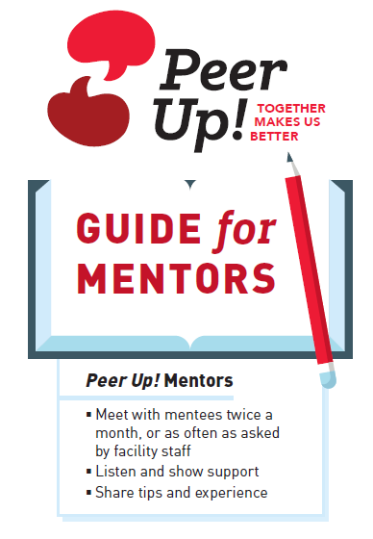  SHOW the Guide for Mentors.  SAY: Your Guide for Mentors outlines how a typical Peer Time might go. It also summarizes the key skills you will learn here today. We will review each of these steps with you during this training. You don’t need to take notes; everything you need is in your guide. Be sure to bring your guide with you to all training sessions. You also may want to have it handy when you meet with your mentee.  Of course, you don’t need to follow this outline exactly. Through listening and empathy, you may find that there are other ways to  support your mentee. But, it is a place to start as you get to know  your mentee.  Before getting started, let’s watch what Peer Time may be like for  most people.

Activity: Video
Show the Peer Mentor Demonstration video: https://www.youtube.com/watch?v=xzYO1dhBU-4&feature=youtu.be
Adaptation: You may wish to role play a Peer Time interaction to demonstrate issues specific to your facility, your participants, or your particular program.
Optional: Patient Education Materials
HAND OUT and REVIEW any additional patient education materials your program or facility provides to mentors
and patients.
Adaptation: If your facility has other patient education materials that are given to all new patients or for specific self-care needs, share and review them during the training.

Summarize
POINT OUT the various skills that were modeled in the video (or role play) of the sample peer interaction.
SAY: These actions, verbal and nonverbal, are what we will discuss as ways to use yourself and your relationship with your mentee to help them in your role as mentor.
Transition
SAY: Because this program focuses on taking care of yourself in dialysis, we will begin with a game to help us review some information about kidney disease.

ESRD Bingo and Review of Self-Care
Learning Objective: Participants can define self-care in the context of ESRD and answer questions about ESRD information.
50 minutes (not including optional review activity)
- Bingo boards (one per participant)
- Highlighters (one per participant) or bingo chips
- Question cards placed in a hat, basket, or bowl
- Prizes
Game Instructions
HAND OUT bingo boards and highlighters.
Randomly PICK a bingo question card and READ the question. (You may also ask a volunteer to draw a card.)
ASK the mentors for the answer. EXPLAIN the terminology or acronym,
as needed.
INSTRUCT players to look over their board to see if the answer is on it. If their board shows the answer, the player covers the square with a chip or mark. The goal is to have spaces marked in a straight line diagonally, across, or up and down.
ANSWER questions from participants about items or ELICIT explanations from other participants.
CONTINUE game until there is a winner or for 20 minutes. Congratulate the winner and hand out the prize.
SAY: Great job everyone! You are all very familiar with information
about ESRD.
Defining Self-Care
SAY: As your care team, we want to provide the best care possible, but most of us have never been patients, so we don’t have the experience that you do. Your knowledge and experience will make you good mentors. Your experience is priceless. Studies show that mentoring is useful to help patients improve their self-care skills.
SAY: When we use the term self-care, we mean the care of oneself without medical, professional, or other assistance or oversight. Self-care skills are actions that patients can take to make their health the best it can be. We are going to focus on the basic self-care skills.
Adaptation: You may wish to role play a Peer Time interaction, to demonstrate issues specific to your facility, your participants, or your particular program. If needed, refer back to the self-care issue in the video (or earlier role play) to generate further discussion.

ASK: What are some ways you take control of your health?
WRITE the self-care skills they practice on a flipchart.
SAY: These self-care skills are some of what you will be helping your mentees to learn.
Optional: Review Key Self-Care Skills for ESRD
SAY: There are five key skills that we include when we say self-care. These are:
Adaptation: Use this section if your participants need additional information based on their knowledge during the bingo game and previous discussion. Or you can integrate the information during the bingo game, as needed. You may wish to use this review activity as a booster session later during the program.

- Following your diet plan
- Limiting fluids
- Taking medications as prescribed
- Coming to all treatments
- Staying the full treatment time
These are important to help you feel good, stay healthy, and avoid hospitalization.
In addition, we want to ensure that you know the best access is a fistula.
Following Your Diet Plan: A renal diet is designed to limit certain elements in your body. Your lab results can tell you how well you are doing with your diet plan. Check your lab results to see how you are doing. Some of the elements tracked in your lab results are:
- Potassium: Potassium affects how your nerves and muscles are working. High or low levels can be dangerous. The goal for most people is 3.5–5.5 mmol/L.
- Phosphorus: Phosphorus is needed for strong bones and healthy blood vessels. High levels can cause soft bones, hard blood vessels, and itchy skin. The goal for most people is 3.5–5.0 mmol/L.
- Calcium: Kidney disease can lower the amount of calcium in your bones. Calcium levels that are too high or too low can be harmful to your bones and heart. The goal for most people is 8.0–10.2 mg/dL.
- Albumin: This protein helps measure how well you are eating. These good protein stores help with wound healing and fighting infection. The goal for most people is at or above 4 g/dL.
Limiting Fluids: Although limiting fluids can be hard, it is very important. Too much fluid can lead to hospitalization. Too much fluid can cause:
- Swelling of your feet, ankles, hands, face, or eyes—called “edema”
- A build-up in your lungs that makes it harder to breathe
- High blood pressure and heart problems like weakened pulse or even heart attack
Keeping track of your fluid and weight can help you stay in control. Take note of your weight each treatment day.
Taking Medications as Prescribed: Taking all of your medicines on time and as prescribed will help you get the maximum benefit and limit side effects. For example, phosphate binders must be taken with meals and snacks.
Coming to All Treatments and Staying the Full Treatment Time: Studies show that missed and shortened treatments lead to shortened lives.
Summarize and Transition
SAY: Now that you have basic knowledge about ESRD, dialysis, and
self-care, we are going to focus on the other traits that make mentors valuable. We are going to walk through, step-by-step, what you will
be doing during Peer Time.

Bingo Questions and Answers
Answers: These are the words or pictures on the bingo boards |   Questions: Cut into cards to pull from hat, basket, or bowl and read to play the bingo game
  ADA | Dialysis patients cannot be fired for missing  some work to have dialysis treatments; they are protected by the __________.
Albumin | This is a protein found in the blood. You need this to build muscle, repair tissue, and fight infection. If yours is low, your dietitian may tell you to eat more protein, like eggs or fish.
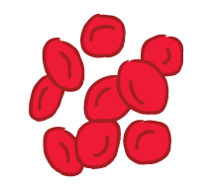  Anemia | If left untreated, this can cause heart damage in people with kidney failure.
  Applesauce | You could use this to take pills instead of drinking  a fluid.
  Baked Potato | Avoid this side dish because it is high in potassium.
  Blanket | You can bring this to keep warm during treatment.
  Blood Pressure | If you bend over after treatment and get dizzy  or light-headed, this could be due to a change in your ________________.
  Calcium | This is pulled out of the bones when phosphorus builds up in the blood.
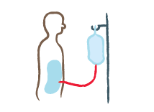CAPD | This is a home treatment option that doesn't use  a machine.
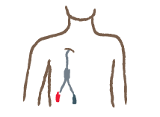Catheter | This type of access has the highest chance of clotting and infection.
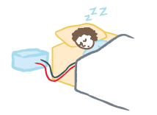  CCPD | This is a home treatment option that uses a cycler machine.
Clamp & Cut | If there is a fire at the center while you are  dialyzing, do this to get off the machine quickly.
Cramps | These can be caused by fluid overload and having  to take off a lot of fluid very quickly.
Creatinine | This lab test measures kidney function.
  Diabetes | This is one of the main causes of kidney disease.
  Dialysate | This is your bath; it is prescribed by your doctor.
Dietitian | This person can teach you about a renal-friendly diet.
  Dry Weight | This is what you weigh without the build-up of  excess fluid.
  Epogen | This is a medication to treat anemia.
  ESRD Network | You can call them if you have a complaint about your dialysis clinic.
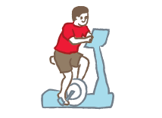  Exercise | Patients doing this regularly have been shown to have fewer hospitalizations.
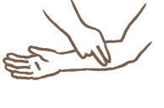Feel the Pulse/Thrill | This is a sign that your access is working well.
Fistula | This is the gold standard of vascular access.
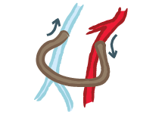Graft | This type of access uses a small, soft tube placed under your skin to join a vein and artery.
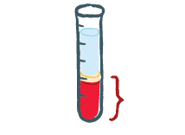Hematocrit | This is a lab test used to detect anemia.
  High Blood Pressure | This is one of the leading causes of ESRD.
  Home Dialysis | Some patients do dialysis at a facility. Others do _______.
  Increase | Your doctor may _______ your treatment time if your URR is low or less than 65%.
Infection | Signs that you have one of these include redness, drainage, and swelling.
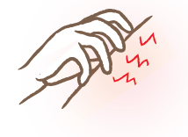  Itchy Skin | This can be caused by an increase in PTH, dry skin, or too much phosphorus in the blood.
  Kt/V | This number tells you how well your blood is  being cleaned.
  Metamucil | This is usually a good over-the-counter choice  for constipation, but always ask your care team  to be sure.
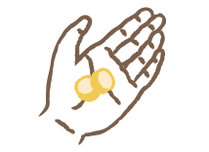Phosphate Binder | You take this drug with meals and snacks to protect your heart and bones.
Phosphorus | This is a mineral found in cola, processed meats,  dairy products, seeds, and nuts and is linked to  bone health.
Potassium | Limiting this in your diet helps to prevent  heart problems.
Protein | You need to eat more of this if your dietitian  says your albumin is low.
  Drink Less Fluid | This is the best thing for you to do if you gain too much weight between treatments.
Relative | This person could be your best chance for a transplant.
Salt | Watching how much of this you use can be  one way to manage fluids. This is another word  for sodium.
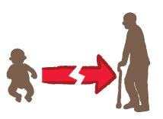Shortened  Life Span | This will happen if you skip or repeatedly shorten treatments.
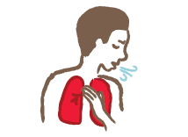Shortness of Breath | You can have this when you miss treatments  and fluid builds up in your blood. It can get worse when you lie down.
  Social Worker | Talk to this person if you are feeling depressed or having a hard time adjusting to life with dialysis.
  Swelling | This happens if you drink too much fluid; it causes swelling of the arms and legs.
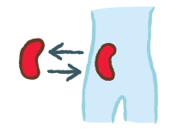Transplant | This is another form of renal replacement therapy;  it is not a cure.
Tylenol | Most dialysis patients can take this  over-the-counter medicine for pain or headaches, but always ask your care team to be sure.
Vaccinations | You should do this to prevent infections and  viruses, including the flu.
Wash Your Hands | This is the best way to prevent the spread  of germs.
You – The Patient | This is the most important person on the  treatment team.

Module 2: Mentor Skills and Techniques
Peer Mentor Role
Learning Objective: Participants can describe mentor-mentee meeting and describe how to greet a mentee.
10 minutes
Flipchart and markers
Introduce Topic
[Relate back to participants’ descriptions of qualities of a mentor during introductions.]
SAY: Communication and support are key skills for mentors. Let’s review some of the skills you will need as a mentor.

REVIEW the Guide for Mentors and provide an overview of what might be discussed during each Peer Time. Be sure to connect topics with what participants stated they wanted to learn or accomplish.
- Greeting/Welcome – Form a relationship, set the tone, establish boundaries, and respect privacy.
- Ask about self-care – Use good communication skills, like open-ended questions and listening.
- Point out/congratulate good self-care – Offer encouragement and provide positive support.
- Ask for one challenge – Help mentee work towards a goal and take small steps.
- Share your experience – Tell your story without giving medical advice.
- Schedule time to talk again.

Discussion
SAY: The first part of your mentoring session is very basic: Introduce yourself, help your mentee feel welcomed, review the purpose of your time together, and establish a friendly and supportive tone.
ASK: Why is it important for us to focus on this step?
LISTEN for these responses:
- Make the mentee feel comfortable.
- Be sure you have similar expectations.
- Establish rapport/connection.
- Set boundaries.
ASK: What are some ways to get a meeting started? What are some things you might say or ask?
SUGGEST:
- Introductions (e.g., starting with a silly question or a fun fact)
- Small talk (e.g., weather, sports, hobbies)
- Sharing background about how long living with dialysis
SAY: One of the key first questions to ask, both in your first Peer Time and in each meeting, is what does your mentee want to get out of your time together? You can ask: “What do you hope to accomplish in this program? Or what to you hope to accomplish during our meeting today?” Your mentee may want to work on one concern or challenge during the entire program, or you may find that your mentee’s priorities change and that they want to address different issues at different times.
INSTRUCT mentors to turn to their neighbors to greet each other, introduce themselves, and share why they decided to become mentors.
PROVIDE positive feedback on the activity. Remind mentors that the guide is for their use to help them remember this first step.
Transition
SAY: An important role for you as a mentor is to be friendly and supportive. But this is different from being a friend. Let’s review how you can stay professional in your role as mentors by setting good boundaries.

Setting the Tone and Setting Boundaries
Learning Objective: Participants will be able to describe their responsibility in maintaining professional boundaries.
15 minutes
Flipchart and markers
Introduce Topic
SAY: The role you have as a peer mentor is valuable and must be appropriate. There are two ways to think about setting boundaries or staying within your professional role as a mentor. The first is to discuss and provide support within the area of dialysis self-care. The second is to remember that your mentee, and only your mentee, is responsible for his or her own care.
Discussion
SAY: We all play different roles in our lives. Our roles in our private lives are different than in our or public lives.
ASK: What are some of the subjects you talk about with your friends and family, but that you keep private at work? LISTEN for two or three answers such as:
- Parenting decisions
- Financial obligations
- Income
SAY: Just as you do at your jobs, you need to set professional boundaries and stay within those limits in the role of mentor. For example, as peer mentors for dialysis, it is not your role to ask about or provide advice for family or financial problems.
DRAW a big circle on flipchart. WRITE the word “Boundary” along edge of circle.
ASK: What are some other topics of discussion that will be outside of your role as peer mentors? WRITE the answers on the flipchart outside of the circle.

LISTEN for:
- Marital problems
- Financial assistance
- Employment
- Mental illness
- Parenting/family decisions
ASK: What are topics of discussion within your role of the peer mentor?
WRITE the answers inside the circle. LISTEN for:
- Asking about dialysis and self-care experiences
- Helping with problem solving
- Sharing self-care tips
- Providing referrals
SAY: Throughout your work as mentors, remember that individuals must be in charge of their own lives. In addition to listening and offering support, it’s important to support the right of people to make their own choices. We accept that they may make choices that are not the ones we would make for ourselves, or that they may choose not to change current habits to improve their health. Set boundaries between your role as mentor and the responsibilities of the person you are trying to help.
ASK: How can trying to fix someone else’s problem keep them from fixing it themselves?
LISTEN for:
- Mentee does not use problem-solving skills
- Solutions don’t match mentee’s needs or wants
- Mentee may feel resentful
- Mentee may begin to rely on mentor to solve problems
- Frustration for both mentee and mentor
- Mentor burnout
SAY: Remember, you can ask for help from facility staff if you are concerned about your mentee’s choices.
ASK participants if they have any questions about setting boundaries.

Summarize
SAY: Your role is to respond to your mentee as much as you can by offering understanding, the knowledge you have, and the experiences you share, all during the amount of time agreed upon. You can also help connect your mentee to other resources, such as the facility staff.
Through all of this, you must remember to stay within your role as mentor for dialysis self-care, and that your mentee is responsible for his or her own self-care. Our staff are here to help you, and you can turn to them whenever you need, especially if you are feeling that you want to help too much.
Transition
SAY: Now that we have reviewed the boundaries of your role, let’s delve into the skills you will use as a peer mentor.

Yes, No, Maybe So: Asking Open-Ended Questions
Learning Objective: Mentors will be able to formulate open-ended questions.
15 minutes
- Flipchart and markers
- Question cards
- Basket
Introduce Topic
SAY: As a mentor, your main job is communication. That is, having conversations with your mentee that show you care, provide support, and show that you understand your mentee’s experience. As we all know, a basic conversation is give and take; each person participates by sharing. In the beginning, you may need to take the lead and get the ball rolling by asking questions.

WRITE three types of questions on the flipchart:
- Closed-ended
- Open-ended
- Opinionated
Discussion
SAY: When starting or continuing a conversation, how you ask a question can affect your interaction and how comfortable your mentee will feel.
DEFINE each type of question listed:
- Closed-ended questions can be answered with a yes or no or with a short, defined answer (such as color, date, or location). These questions are useful for clarifying facts, but they do not allow the other person to elaborate.
- Open-ended questions have no defined answer. These often
begin with who, what, where, how, or why?
- Opinionated questions suggest the answer to the mentee,
or show judgment. For example, “You know it’s bad to drink
soda, right?”
ASK: Which type of questions are the most useful for starting a conversation?
PLACE a star or underline Open-ended on the flipchart.
Summarize and Introduce the Activity
SAY: One way to make people feel comfortable and willing to share information is by asking open-ended questions. Inappropriate questions can make a mentee feel uncomfortable or limit his or her answers.
In this activity, we will take a look at some questions and decide if they are useful for creating connection and understanding, or if they are unhelpful or inappropriate.

Activity
INSTRUCT each participant to pull a card from the basket, read it to the group, and state what type of question is on the card (open-ended, closed, opinion).
For all questions that are
not open-ended, ASK the participant to propose an alternative, more helpful question.
Adaptation: Turn this activity into a game for groups with ambulatory participants. Create two teams to play against each other. Draw the cards, and have teams press buzzers or ring bells to answer first. Teams earn points for every question they rephrase.

CONTINUE until all the
cards are used or you feel participants have grasped
the concept.
ASK:
- What was easy about rephrasing questions?
- Which ones were harder to rephrase? Why?
- How will this skill help you during Peer Time?
ASK participants if they have any questions about how to use open-ended questions.
Transition
SAY: As I mentioned, a good conversation is two way. As you ask questions and show support, you must also listen fully to your mentee. Let’s look at some skills to be a good listener.

Cards for Yes, No, Maybe So: Asking
Open-Ended Questions

How much  did you drink yesterday? | What have you heard  about potassium?
Don’t you think you should  eat more healthy? | What concerns have the staff  had about your health?
How many treatments  have you missed? | Do you eat with your family  or alone?
Tell me how you  keep track of your fluids. | When would be a good time  for us to meet?
I think you should have told the technician, don’t you? | Can’t your wife drive you  to the facility?
Tell me more about  the days when you feel well. | Aren’t you worried about your health?
Don’t you think it’s better to  watch your fluids than to  feel uncomfortable? | Tell me more about how  your meals are prepared.
What was the lab result? | Tell me what you hope to get  from the Peer Up! program.
Why haven’t you made  any changes to manage your  kidney disease? | What differences do you  notice between how you feel  now and how you felt before  your treatment?
Being a Good Listener
Learning Objective: Mentors can name and explain characteristics of effective listening.
10 minutes
WRITE three skills on flipchart:
- Repeat
- Rephrase in your own words
- Ask for more details
Introduce Topic
SAY: As a peer mentor who has similar experiences and challenges as
other people with renal disease, you have the unique opportunity to understand what others are going through and offer support. During Peer Time, your mentee may have a number of topics he or she would like to share. You offer important support by simply listening fully to their experiences and concerns.
Discussion
SAY: Effective listening is a fundamental part of being a mentor.
ASK: What might happen if you do not listen carefully to a mentee?
LISTEN for the following responses:
- You might end up with wrong information because you missed what someone really said or thought you heard something you
did not.
- You might miss a good opportunity to get at the heart of your mentee’s concerns.
- You might leave your mentee feeling ignored or offended if you don’t take into account what he or she said.
SAY: Remember, mentoring is not about you, and you don’t have to carry the conversation. Silence can be golden, as they say, and simply listening and showing that you’re listening may be most important. Your mentee may provide you with all sorts of clues and information if you simply allow them to talk and fill the silence.
ASK: Think of what you saw in the Peer Mentoring Demonstration video (or role play). What kind of body language did the mentor use to let the mentee know she was listening?
LISTEN for responses such as:
- Nodding head
- Making eye contact and showing attention to speaker
- Leaning in
- Keeping a friendly expression while you listen.
ASK: What are some ways to listen fully? LISTEN for responses such as:
- Keep your mind centered on the other person. Try to put yourself in that person’s shoes and understand what he or she is thinking.
- Try not to interrupt or finish the other person’s sentences.
- Watch the other person’s facial expression and body language.
SAY: Allow for silence and space between questions. People need time to think about what they are going to say. You need time to understand what is being said. A pause might make you feel uneasy, but it’s a natural part of conversation and necessary to allow time to understand what’s being asked or said.
SAY: Showing that you are listening is a key skill. In addition to using your body and your face to show you’re listening, you may also ask questions or respond in a way that shows you are paying attention. By confirming that you understand what you heard, you are telling the other person that what they say is important and valuable.
REFER to the Guide for Mentors.
ASK: What are some way you can verify that you truly understand what a mentee has said? LISTEN for:
- Repeat: During a conversation, you may repeat what you heard using the person’s actual words. This helps the person expand more on what he or she said.
For example, “So, you said you became worried when your numbers were high….”
- Rephrase in your own words: Use your own words to tell a mentee what you think they are trying to say. This helps the person clarify or correct your impression.
For example, “It sounds like you were worried when that happened….
- Ask for more details: When you do not understand what is being said, try to clear up the confusion by:
- Asking: Can you tell me more about that?
- Repeat their words, then pause.
- Say what you think they said, then pause.
SAY: What you hear is what people actually say with words. But often we make assumptions about what people have said based on their words, their nonverbal signals, and our own previous impressions and experience. As a mentor, it is important for you to listen fully to understand what is being said, and that you don’t make assumptions. You don’t want to jump to conclusions or solutions.
Summarize
SAY: By listening fully to your mentee, you can provide support and help clarify underlying concerns. Refer to your mentor pocket card if you need reminders on how to listen fully.
Transition
SAY: We’ve just discussed some ways that you can show your mentee that you are listening. Let’s take this a step further and discuss how you can give positive feedback and encouragement to help your mentee feel supported in their self-care.

Offering Praise and Encouragement
Learning Objective: Participants can demonstrate providing
positive feedback.
15 minutes
Encouragement Activity handout (one for each participant)
Introduce Topic
REFER to the Guide for Mentors.
SAY: During Peer Time, you should ask questions about how your mentee is doing, feeling, and practicing self-care. One of the important ways you can respond to what your mentee says is to point out good self-care and offer encouragement. Let’s review and practice what we mean.
Activity
Adaptation: Allow extra time for reading assistance to participants with visual impairments.
BRAINSTORM: What is the meaning of “encouragement”?
SHARE a definition: To inspire with hope, courage, or confidence.
ASK: What does encouragement mean when talking with another patient from the dialysis unit?
BRAINSTORM: What is the meaning of “praise”?
SHARE a definition: Express approval, commendation, or admiration.²
ASK: What does praise mean in the context of self-care?
ASK participants to get into pairs. HAND OUT the activity and ask pairs to work together to write encouraging responses to each statement.
ALLOW pairs to work for five minutes.
ASK two to three pairs to share their responses. MODEL positive feedback for their work. For the “I had a great week” statement, coach participants if they don’t respond with something like “That’s great, but how will you continue to keep doing well?”
Summarize
SAY: The simple act of offering encouragement and praise when your mentee shares his or her attempts and successes is one of the key benefits you can offer as a mentor.
Transition
SAY: While you may practice praise and encouragement in your Peer Time, there may be times when your mentee is feeling discouraged and challenged. Let’s take a look at some strategies to help your mentee in those cases.

Encouragement Activity

For each statement, write a response that points out the positive, praises
self-care, or offers encouragement.

Mentee says: Yesterday, I measured the amount of fluid I drank so I could
get a better idea of how much I was drinking.
Mentor says: __________________________________________________________________
__________________________________________________________________

Mentee says: I was so tired, but I still came to my treatment.
Mentor says: __________________________________________________________________
__________________________________________________________________

Mentee says: I had a great week. I don’t need to work on anything.
Mentor says: __________________________________________________________________
__________________________________________________________________

Encouragement
Activity

For each statement, write a response that points
out the positive, praises self-care, or offers encouragement.

Mentee says: Yesterday, I measured the amount of fluid I drank so I could get a better idea of how much I was drinking.
Mentor says: ______________________________________________
______________________________________________

Mentee says: I was so tired, but I still came to my treatment.
Mentor says: ______________________________________________
______________________________________________

Mentee says: I had a great week. I don’t need to work on anything.
Mentor says: ______________________________________________
______________________________________________

Keeping It Positive
Learning Objective: Mentors can demonstrate four skills for keeping conversation positive and productive.
5 minutes
Flipchart and markers
Introduce Topic
SAY: In addition to being a good listener and asking questions that keep a conversation going, you may need other skills in times when your mentee is feeling discouraged or being negative. We all know how difficult it is to make changes in our lives, and how it can be discouraging to try and not succeed. You can show support by listening and by using other skills, if needed.
WRITE four skills on flipchart:
- Reflect
- Reframe
- Redirect
- Take a break
Discussion
SAY: It can be awkward or challenging to try to support someone or have a conversation if the general tone is negative or one of discouragement. Here are four things to try to help the conversation with a mentee stay positive and productive. These are also listed in the Guide for Mentors if you need to review them later.
Remember, you are not trying to change your mentee’s feelings or plans, but simply trying to keep the conversation and the time spent together as productive and helpful as possible.
- Reflect: Say back what you think your mentee is feeling, like the reflection in a mirror. For example, you can say, “You sound frustrated,” or “You sound discouraged right now,” or “You do look tired.” Sometimes, people just want to have their feelings known and that makes them able to continue the conversation more productively.
- Reframe: You can reframe a problem or situation by pointing out another way to look at it. It’s like putting a new frame on a picture. For example, your mentee says, “The dietitian is always on my case.” Reframe: “So, she brings this up once a month during your treatment? So, not all of the time? It sounds like she cares about you and wants you to be as healthy as possible and to make your dialysis treatments as easy as possible. What would make you feel okay about this?”
- Redirect: If a conversation topic does not seem to be going anywhere, simply say that it is time to talk about something else. “Let’s talk about what you ate yesterday,” or “Let’s take a look at the information on this page.”
- Take a break: If these tips don’t help, you can end your conversation for that session, but be sure to make a plan to meet again or talk by phone.
Summarize
SAY: These are four things you can try if you feel the conversation
is difficult or not productive. Refer to your mentor guide if you
need reminders.
Transition
SAY: We have just reviewed some tips to keep the conversation productive. As we discussed earlier, your role as a mentor is to listen, empathize, and provide support. We also hope that you will be able to help increase your mentee’s confidence and motivate your mentee to take action to self-care. Let’s look at this next.

Building Confidence and Motivating Others
Learning Objective: Mentors will be able to demonstrate two skills for motivating others.
Adaptation: This activity can be postponed and taught later in the program. It works well as a booster session for mentors.

40 minutes
- Flipchart and markers
- Tape
- Stages of Change handout
Label and post the Stages of Change flipchart pages (in order, showing a continuum): “Not ready,” “Thinking about it,” “Planning,” “Trying,” “Sticking with it.”
Introduce Confidence
SAY: The core of the Peer Up! program is to help increase the confidence of your mentee in doing self-care. People who feel more confident are more likely to try to take steps for self-care. People who feel discouraged or down are less likely to take steps for self-care. We can’t change how people feel, but we can try to help boost their confidence through support, understanding, and sharing experiences.
Discussion
ASK: How would you define “confidence”?
WRITE answers on flipchart. LISTEN for:
- Belief in self
- Self-assurance
- Belief you can succeed
- Power to do something
ASK: From your experience, how would you describe having confidence in doing self-care and living with your renal disease?
ALLOW two to three mentors to respond.

If needed, provide the following examples:
- Belief in yourself that you can feel better
- Know I can get myself to treatment
- Find ways to follow my diet
ASK: What do you think gave you such confidence?
If needed, provide the following examples:
- Family support and caring
- Faith
- Belief in myself
SAY: Your expertise in learning to care for yourself is valuable; you can share that experience with others.
Introduce Motivation
SAY: Next, let’s look at the ways you can support and build the confidence of your mentees. Specifically:
- Motivate
- Problem solve and share tips to build confidence
First Skill: Motivation
SAY: There are many reasons we feel motivated to do things, but the most common reason for doing something is that we get something out of it. That is, there is a benefit, or a good thing that will happen or that we believe will happen. If we go to the grocery store and pick out an item, we believe that it will taste good, we will enjoy it, or someone in our family will like it. Humans don’t want to do things that don’t have a good result.
Let’s take a look at how we can help others feel motivated to take a step toward self-care.
Discussion
ASK: First, let’s think about some of the reasons you are all here today; you stated some of those reasons in our introductions. What are some of the benefits or good things that you think will come from being a mentor?
WRITE answers on flipchart:
- Make friends
- Feel helpful
- Do something good
- Occupy time
SUMMARIZE answers and REINFORCE that participants will get positive experience out of being mentors.
ASK: If you would like to share, what are some of the reasons you think you are taking good care of yourselves, or others you know are doing things to take care of themselves?
WRITE answers on flipchart. If necessary, PROBE: For others (friends/family)? To feel better? To be able to enjoy something else? To live a long life?
SUMMARIZE answers and POINT OUT that different people will have different reasons for wanting to do things.
SAY: When you meet with your mentee, one of the skills you should feel comfortable with is asking about what is important to the other person. That way, you can encourage your mentee to practice self-care for those important, personalized reasons.
BRAINSTORM ways to ask mentees about what they enjoy in their day-to-day lives that feeling healthy will help them maintain.
ASK: How might you ask your mentees about what is important to them? For example: What do you like to do on days when you don’t have treatment?
REPEAT or REPHRASE questions suggested by participants to reinforce open-ended question skill.
ASK if mentors have any questions about benefits or reasons for doing self-care. REMIND participants of the mentor guide for their use.
Introduce Second Skill: Overcoming Challenges
SAY: The second way you can help motivate your mentee is to talk with them about what makes it difficult to practice self-care, and what are the ways they might be able to overcome the difficulties. An important part of that discussion is understanding where they are in their motivation, and how you can help them without applying too much pressure. Let’s try this ourselves.
Stages of Change Activity
POINT OUT Stages of Change flipchart pages on the wall. HAND OUT Stages of Change handout.
SAY: Whenever people are trying to learn something new or change a habit, they go through a series of phases. These are called “stages of change.” We don’t suddenly become experts at managing our fluids or changing how we eat. It takes time and effort, going through a number
of phases.
These stages came from studies about smokers. Researchers found that smokers did not quit right away. They had to go through stages.
Briefly EXPLAIN the stages using the handout.
ASK: Are there are any former smokers in the group?
ASK those participants: Were you able to jump from thinking about quitting to completely quitting smoking?
REINFORCE that people need to take time to go through the stages and sometimes even go back to previous stages, like trying to quit smoking.

Exercise Discussion
SAY: Let’s take a look at what stages we are in for exercising. We all know that we should exercise often to stay healthy. Some recommend that we should get an hour of exercise three days a week. How many of us are doing that now?
Adaptation: For groups of ambulatory participants, have participants get up and stand
by the flipchart page with the appropriate stage of change.

ASK participants to raise their hand
if they are regularly exercising three days a week.
WRITE the number of raised hands on the flipchart page labeled “Sticking with it.”
CONTINUE to ask for raised hands and write numbers on the appropriate flipchart page:
- How many of you exercise each week, but have not yet gotten to three times a week?
- How many of you plan to exercise, maybe do it once in a while, but often don’t get to it?
- How many of you have thought about exercising but not started doing it?
- How many of you don’t have any interest at all in exercising three times a week?
ASK: If you were told, “Exercise is good for you,” would it help you commit to exercising?
SAY: Being told what is good for us is not usually enough to motivate us.
Different people have different habits and levels of interest in a behavior. These differences also apply to self-care. To encourage people to try to change, you need to respect these differences.
ASK the “Not ready” group: Will you be exercising three times next week?
SAY: We can’t expect people in one of the early stages of change to jump right to the last stage.
ASK the “Not ready” group: Will you be willing to talk about exercising, and maybe learn about some options?
SAY: People in each stage can more easily be motivated to move to the next stage.
ASK mentors for questions about stages of change.
Stages of Change in Dialysis
ASK: In the Peer Mentoring Demonstration video (or role play) at the beginning of the training, what clues might help you to know what stage of change the mentee was in?
LISTEN for the following responses related to the video; other answers may apply if you did your own role play.
- The mentee said she tried to watch her fluids, but had a hard time.
- The mentee measured her fluids in the morning, but gave up by the end of the day.
- The mentee intended to only sip water with pills, but then drank a lot more.
ASK: What stage do you think the mentee was in?
LISTEN for: “Trying” stage.
ASK: What could you say to help her get to the next stage, “sticking with it?”
LISTEN for answers such as:
- Suggest chewing gum or eating hard candy when thirsty.
- Encourage her to carry a bottle with measurements on it to better track fluids through the day.
- Suggest taking pills with applesauce instead of fluid.
For each of the statements that follow, DISCUSS the stage of change the mentee is in. ASK mentors what questions they might ask or discussions they might have with a person in that stage of change.
- I plan to drink only a little, but then I get really thirsty.

- It’s all so difficult; I can’t even find a way to start.

- I have attended my dialysis treatments as scheduled for the last six months.

- I know I should take care of myself, but I’m not sure how.

ASK: When you have found yourself in a particular stage, what would have been helpful to you to move forward? ASK for several
“tips” or self-care activities in which they have shown progress at
various stages.
Introduce “Small Steps”
SAY: Another important way you can help your mentees is by helping them think of small steps they can take to try some changes. Again, remember what stage they are in: you can’t expect someone who has no interest in changing to jump right into a full renal diet. However, a small step might be to review their diet plan twice a week to remind them of what is on it.
Small steps are better than no steps. For example, if your mentee is consistently cutting his or her treatment short by 5–10 minutes each time, help your mentee set the goal of staying for the full treatment time at least once per week. Celebrate the success, and the next goal would be staying for the full treatment time at least two times per week.
ASK if mentors have any questions about stages of change or small steps.
Summarize
SAY: As you listen to and ask questions of your mentees, respond to them in a way that helps them where they are in their beliefs and views about self-care. You will be most supportive if you don’t push, but instead offer options that are relevant to their current stage of change and reflect how they are feeling and what they think they can do. Refer to your pocket card for suggestions on how to motivate and build confidence with your mentee.
Transition
SAY: Part of helping your mentee is sharing some of your own experiences—within professional boundaries. Let’s take a look at
that next.

How to Respond Based on Stages of Change
If your mentee is: | Then discuss this:
Not ready | - Reasons and benefits for change  - Getting more information  - Learning how  - Who can help
Thinking about it | - Think of times or ways it will be easy  - Find support (such as a relative or friend)
Planning | - Pick a day to try something  - Pick one small step to try  - Find support (such as a relative or friend)
Trying | - Repeat what worked before  - Celebrate when successful
Sticking with it | - Encouragement!  - Problem solve if have a relapse

Medical Information vs. Medical Advice
Learning Objective: Mentors can describe the difference between sharing medical experience as compared to providing medical advice.
 | 15 minutes
Introduce Topic
SAY: We want you to share your story. You know best what another patient is going through because you may have experienced it yourself. However, we need to be careful in providing medical advice.
The difference between medical information and medical advice can
be confusing.
Discussion
SAY: It is okay to share your story, but you cannot tell a mentee about what they should do medically, such as be evaluated for a transplant
or switch doctors.
Avoid:
- Giving an opinion about a particular type of treatment
or surgery
- Recommending a health care provider or where to go for
medical care
When you share how you have handled a particular challenge or situation, you can use the phrase:
“What worked for me was…”
AND
“Talk with your provider to see if that might work for you.”
For example:
“I started to measure my fluids everyday so I have a better idea of how much I was consuming. If you think that might help you, talk to the dietitian to see what she thinks and how many ounces you can have
per day.”
“I had read in a pamphlet that rinsing off canned vegetables can help reduce your salt intake. So I asked the dietitian about it. If you think that might help you, you could talk to the dietitian.”
Some other examples might include…
Medical Advice |  | Medical Information
Opinion |  | Objective
You should soak your potatoes. |  | One thing I have learned is to soak my potatoes for several days.
That sounds like angina to me. You should have that checked out by a cardiologist. |  | Tell the charge nurse and see what she recommends.
It sounds like you really hate dialysis. Why don’t you try to get a transplant? |  | There are other treatment options for kidney failure. Have you talked about your options with your doctor?
You need to get an AV fistula. You don’t want to end up with a nasty infection, do you? |  | AV fistulas are recommended for dialysis patients. Have you talked with your doctor about what type of vascular access would be best for you?
SAY: It is okay and helpful to share things that have worked for you, but you should always add a “disclaimer.” Always encourage mentees to check in with someone on their health care team before trying something new. Just because something was helpful or worked for you does not mean it is right for your mentee.
If you’re comfortable doing so, you may offer to accompany your mentee to talk to the dietitian, charge nurse, or other facility staff the first time a question or issue comes up. You can model the behavior—that is, ask the question(s) as the mentee should so that the mentee develops the confidence to do so next time on his or her own.
Summary
SAY: You do not have to be a doctor or give medical advice; mentees already have a doctor and charge nurses. You do not have to be their social worker or their dietitian either. You can help your mentee by just listening, being respectful, and letting him or her know that you have been there.
Transition
SAY: You can offer support as someone they can trust who has shared similar experiences. Respect and trust come from keeping personal information private. We call that confidentiality. Let’s discuss that
topic next.

Maintaining Confidentiality
Learning Objective: Mentees can describe the meaning of confidentiality and identify at least four exceptions and reporting procedures.
15 minutes
Flipchart and markers
Introduce Topic
Adaptation: Tailor this section to address confidentiality policies and protocols in your facility. Consider asking mentors and mentees to sign confidentiality agreements. (A sample is available in the Peer Up! Program Toolkit.)

SAY: During Peer Time, mentees will tell you things related to their health and maybe even information about their personal lives. A key part of being a good mentor and having a trusting relationship is making sure that what your mentee tells you in private stays with you.
In other words, do not share with anyone what your mentee tells you. This is referred to as maintaining confidentiality.
But there may be some instances in which, for the safety and well-being of your mentee, it may be necessary to tell designated staff at the health facility information that your mentee has shared with you.
REVIEW the section on confidentiality in the Guide for Mentors.
Confidentiality: Do not talk about your mentee with other patients, friends, or relatives.
Exceptions: Get help right away if your mentee talks about:
- Harming himself or herself (e.g., thinking of suicide)
- Being harmed by others (e.g., domestic abuse)
- Stopping medical treatment
- Using a different or alternative medical treatment without approval
- Other information indicating they may be in danger
Reporting
WRITE on flipchart the name and contact information of the designated person in the health facility to report concerns.
SAY: If you’re not sure about what exactly falls under these categories, err on the safe side and get help from a staff member.
Discussion
SAY: As a general rule, anything your mentee tells you is being said in confidence. It is something that the mentee is choosing to tell you, and it is your responsibility as a mentor to respect your mentee’s right to keep that information private by not sharing it with others. Maintaining your mentee’s confidentiality is a key part of your role as a mentor.
Confidentiality goes both ways. Ask your mentee to keep any personal information you share private. For instance, if you share that when you started dialysis, you went home after every treatment and cried, you may not want that shared with others. If your mentee can trust that you will not share what he or she tells you, your mentee will be more likely to do the same for you when you share your own experiences.
Be sensitive to where you meet. Make sure it is a place that you and your mentee feel that you can talk openly.
Summary
SAY: Confidentiality is a key part of your role as mentor and important to building and maintaining your mentee’s trust. Confidentiality means not sharing with others—including your own friends and family, other patients, and strangers—information your mentee shares with you during your meetings. However, there are some exceptions, such as when something your mentee said suggests he or she may be in danger. As a mentor, it is important that you are aware of and identify specific cases in which you may need to communicate information your mentee tells you to designated personnel in the health facility, and that you follow the facility’s guidelines for reporting this information.
ASK if there are any questions about confidentiality.
Transition
SAY: This concludes our overview of the skills you will use for your peer mentoring sessions. Now let’s work to put them all into practice.

Module 3: Practice in Pairs
Mentor-Mentee Practice
Learning Objective: Participants will demonstrate mentor skills, including active listening, reframing, motivating, and providing
self-care tips.
40 minutes
Practice cards (one per participant)
Introduce Activity
SAY: We have covered a lot of information today, and we thank you for your focus and participation. In this last section of the training, we are going to give you time to practice some of the skills you’ve learned and give you some time to think about how you would like to use all of this information in your role as a mentor.
Activity
SAY: For this activity, we are going to ask you to find a partner. You will each get a chance to practice being a mentor and a mentee. We will hand out scenario cards for each of you, describing different situations that you may face as a mentor.
Read your card out loud and use the instructions to practice the situation with your partner, acting as the peer mentor. Then switch roles, and your partner will be the mentor. I will call time when you should switch so you each have enough time to practice.
When you have your turn as a mentor, remember to:
- Listen fully
- Provide support, encouragement, and motivation
- Keep the conversation productive
- Refer to your mentor guide as needed
ASK for any questions from the participants.
ASK participants to get into pairs.
HAND OUT practice cards.
CIRCULATE around the room to provide support and assistance.
CALL TIME after seven minutes. ASK partners to give feedback to mentor.
CALL TIME again after three minutes to start next practice. REPEAT for second round.
Debrief
ASK mentors:
- What did you find easy during your practice as the peer mentor?
- What did you find difficult during your practice as the peer mentor?
- What were some of the skills you used?
- What did you learn from your practice that you would suggest to other mentors?
THANK the participants for their good work.
As you circulate around the room during this activity, notice how people are interacting and watch for any red flags. If someone is espousing religious or political information, or just doesn’t seem to be catching on to the material, they may not be a good fit for being a mentor. Consider talking to them one-on-one to express your concern and suggest other ways they may become involved in the center.
Transition
SAY: You have all learned so many skills and ways that you can help. We look forward to working with you to support the mentees. Our final segment of the training is to acknowledge your accomplishments.

Peer Up! Practice in Pairs Scenarios

Read aloud:
Use this situation to practice how you would start a first meeting.
You are meeting your mentee for the first time. You know this mentee by name only. You are not friends, and you do not know anything else about this person.
Take five minutes and begin to engage the mentee in your first Peer Up! meeting. Use the Guide for Mentors to help you get started.

Start the conversation by saying, “Hi, I am (name), and it’s nice to meet you.”
Read aloud:
Use this situation to practice how you would start a meeting.
You are meeting your mentee for the third time. You know that
your mentee has been struggling with fluid intake. She is drinking
1 liter of iced tea a day, in addition to other drinks and fluid-heavy food. Her husband also drinks a lot of iced tea, which makes it difficult for her to resist.
You also struggled with this early on in your treatment: Iced tea is
one of your favorite drinks! You have found ways to enjoy it and still stay within your fluid plan.
Take 5 minutes and start a discussion about the challenges of fluid intake. Start the conversation by saying, “So, (mentee name), it sure has been hot lately. It’s been hard staying within my fluid limits. How have you been doing with that?”
Read aloud:
Use this situation to practice the skills of being a good listener.
You and your mentee are meeting for the fourth time. She is eager to discuss her dialysis treatments and hear your thoughts on ways to make her treatments easier. She gets bored and so hungry during her treatment times.
Use good listening skills by repeating, rephrasing, and asking for more details to guide this conversation.
Read aloud:
Use this situation to practice the skills of keeping a conversation positive and productive.
You and your mentee, Mr. Smith, are meeting for the second time.
He is not as pleasant as he was in your first meeting. He is upset with the dietitian as she’s trying to “limit his fluid too much.” He cannot believe that his nephrologist has put him on yet another medicine!
The conversation is becoming more difficult, but you feel that you
can continue to talk with him and help him to “see the good” in what his care team is trying to do for him. Use reframing to guide your conversation.
Read aloud:
Use this situation to practice skills in motivating and building confidence.
You and your mentee, Mrs. Jones, are meeting. It is Mrs. Jones’ anniversary. She and her husband are planning a dinner out at a fancy restaurant to celebrate. She wants to feel the best she can for the special dinner, but worries that she will have already met her fluid intake maximum for the day.
Guide the conversation so that you and Mrs. Jones discuss what
has worked for her in the past around daily fluid management and how she can repeat that past success for her special dinner with
her husband.
Read aloud:
Use this situation to practice staying professional.
Your mentee is having difficulty remembering to take afternoon
pills between meals. He says that his wife should help him remember to do this; after all, he sees it as “her responsibility.”
Use what you’ve been taught about staying professional and guide this conversation to share a tip that has worked for you in remembering to take your afternoon medication.
Read aloud:
Use this situation to practice avoiding giving medical advice.
Sally recently began treatment at your facility. She currently has a catheter. Her doctor and the staff all recommend that Sally have a permanent vascular access, like an AV fistula, placed.
Yesterday, Sally was talking to a friend whose husband is on dialysis. She told Sally that her husband had nothing but problems with his
AV fistula and wishes he just would have kept his catheter. It seems
to get clotted all of the time, and it hurts every time he is stuck. Sally is fearful of the surgery and really doesn’t want to experience pain during her treatments. She asks you what you would do.
How would you respond?
Read aloud:
Use this situation to practice getting additional help.
You sit down to talk with Mrs. Lynn, your mentee. You notice
that she is just not herself today; what she’s saying doesn’t make sense, she seems to be very tired, and she is having trouble staying awake.
What would you say? How would you handle this situation? What are your next steps?
Read aloud:
Use this situation to practice getting additional help.
Mr. B, your mentee, is eager to talk today. After your initial greetings and welcome, he says that he is especially interested in discussing his potassium levels (which were high), your thoughts on developing a diet plan to limit potassium-rich foods, and how much salt he should be taking in over 24 hours.
How would you handle this situation?

Training Certificates and Closure
Learning Objective: Mentors receive acknowledgement of training completion and provide feedback to the trainers.
20 minutes
- Certificates (one per participant)
- Feedback forms (one per participant)
Activity
Adaptation: As an optional activity, take photos of the mentors holding their certificates to post on an announcement board or to share in facility news. Ensure that all participants understand usage and provide consent before taking any photos.

HAND OUT certificates
and THANK each
participant individually
for his or her participation and hard work. (Certificates are available in the Peer Up! Program Toolkit; a sample is shown at the end of this section.)
HAND OUT training feedback forms, and allow each participant to complete.
Closing
Congratulate participants.
Provide any next steps or program information for upcoming meetings.

Mentor Training Feedback

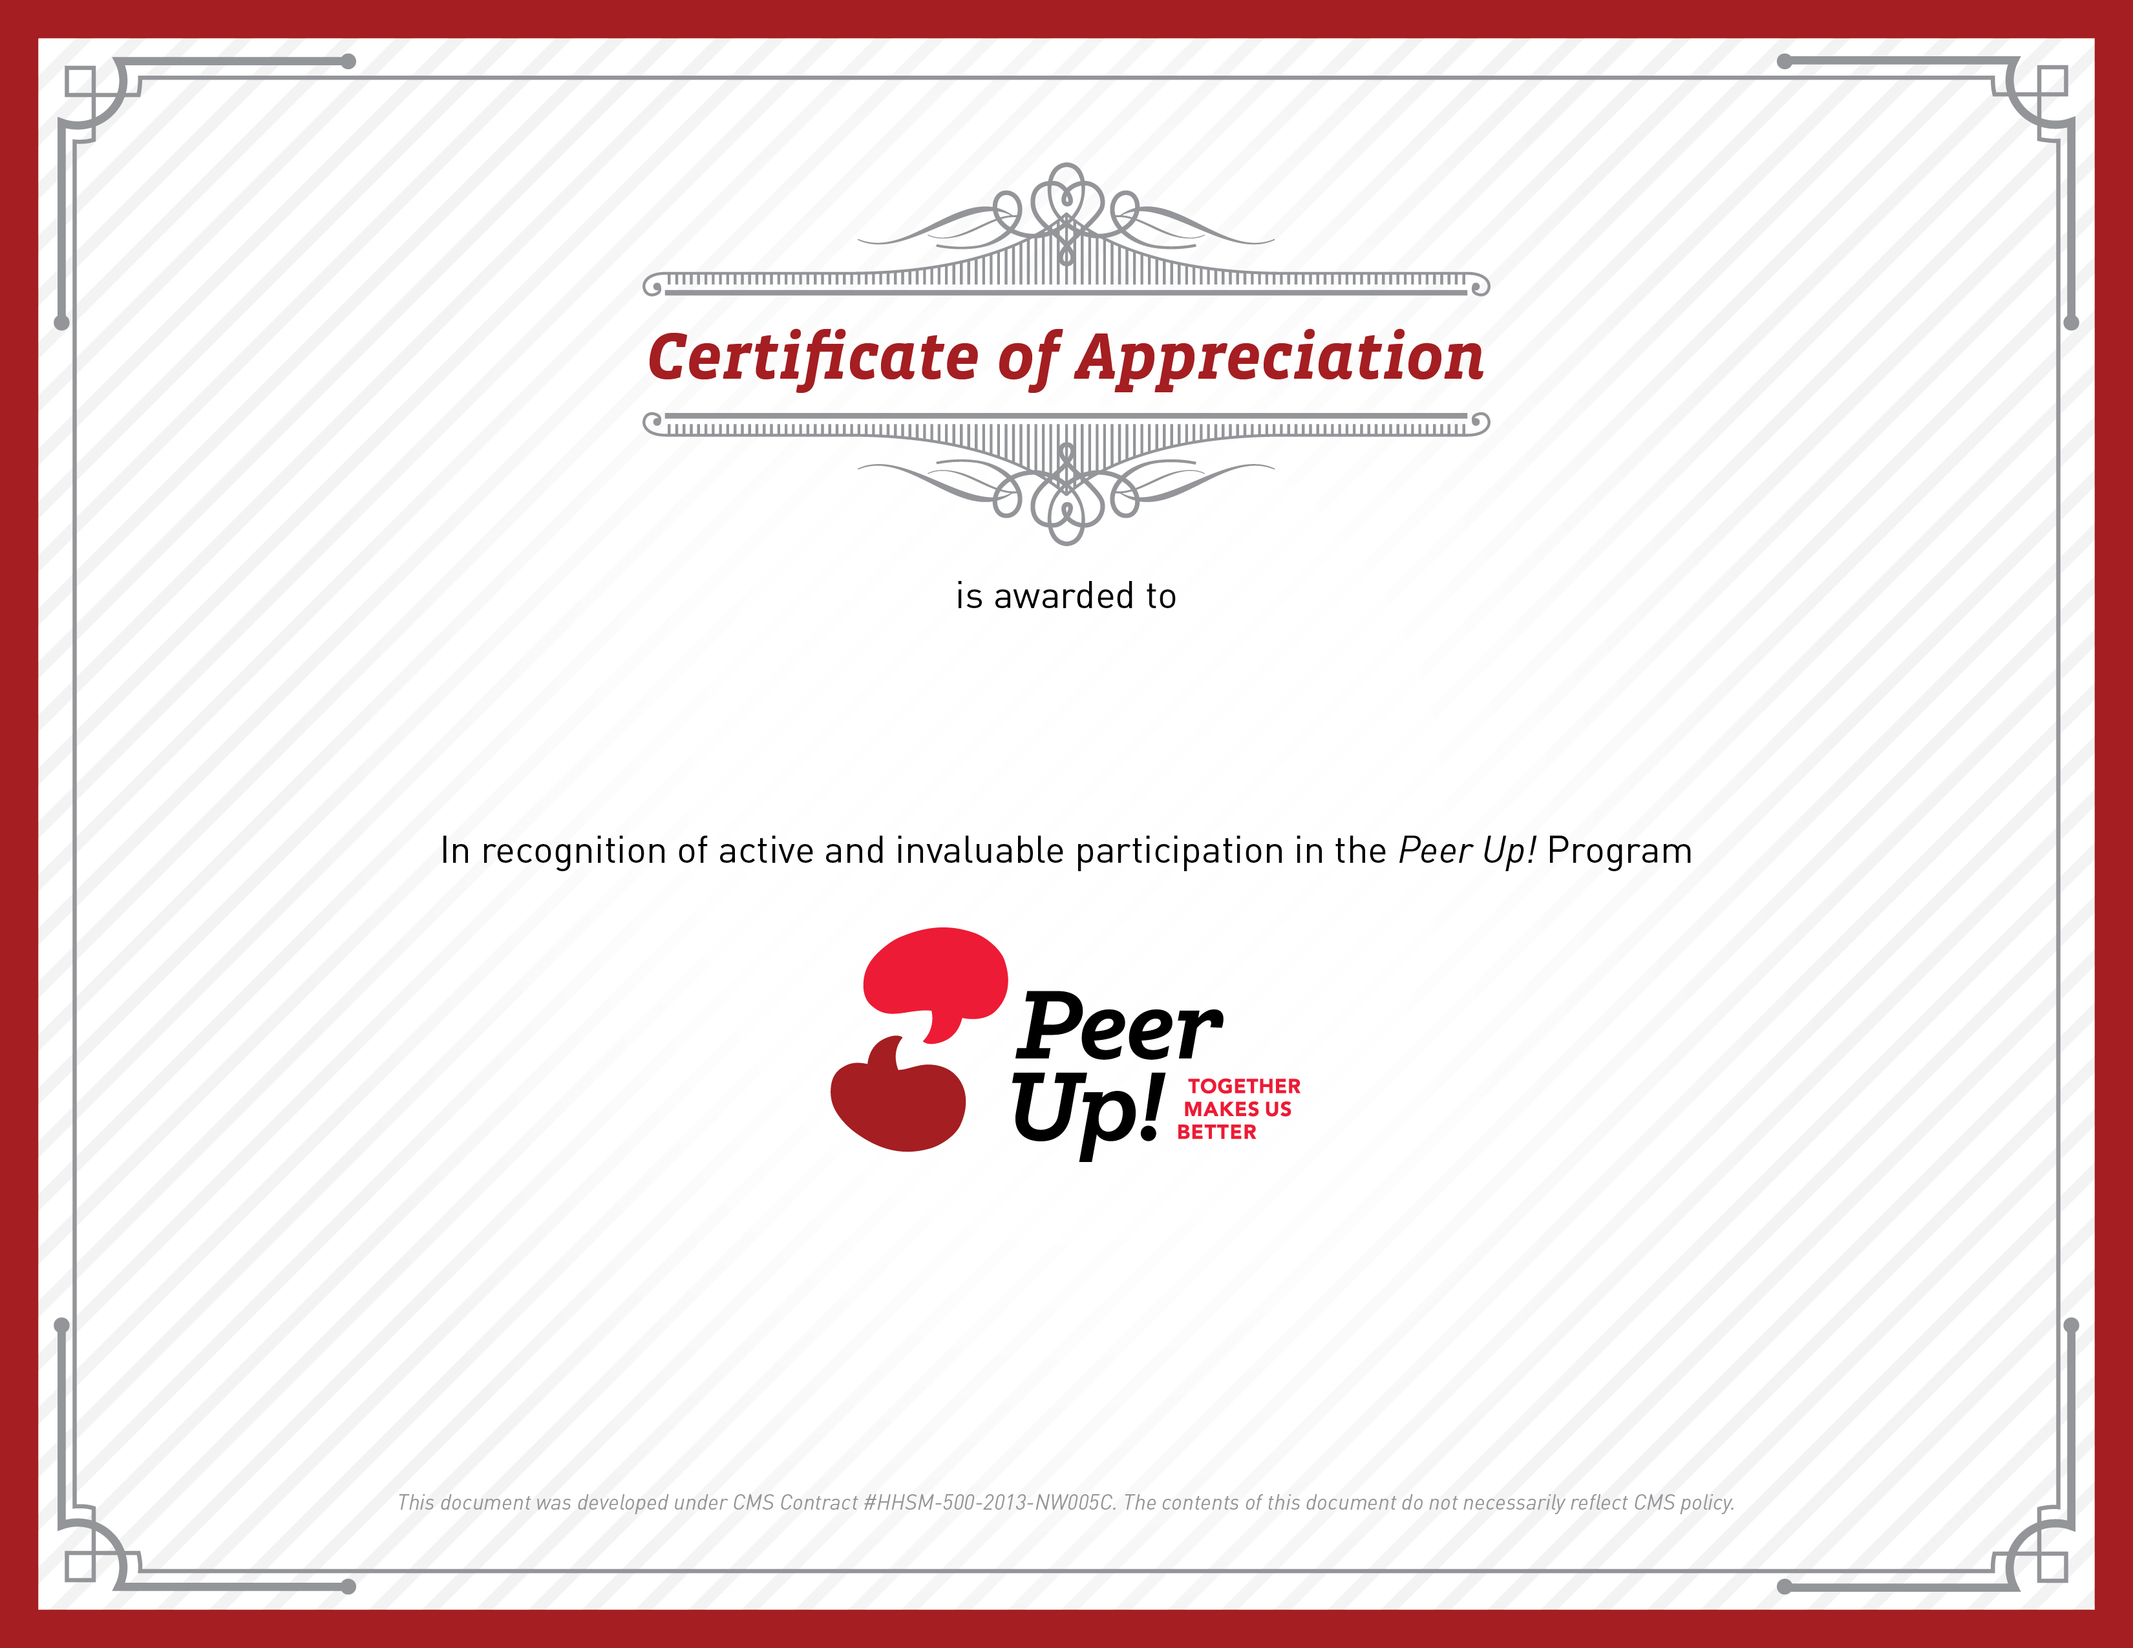
Please tell us how confident you are in using your mentoring skills.
 | Totally confident | Somewhat confident | Not very confident | Not at all confident
- I can share tips and experience about living with kidney disease.
- I can name three characteristics of a good mentor.
- I am able to use my body to show someone I am listening.
- I am able to respond to someone to show them I heard what they said.
- I can ask an open-ended question.
- I can help a mentee find small steps toward self-care goals.
- I can use praise and encouragement during a conversation.
- I can lead a Peer Up! meeting.
- I can keep information private.
- I can set a professional boundary with my mentee.
- I can ask for help from facility staff or other mentors.
- I can keep a conversation on a positive tone.
Please provide your feedback on the Peer Up! mentor training.

 | Strongly Agree | Agree | Disagree | Strongly Disagree
- The trainers were well prepared.
- The handouts were clear and easy to read.
- The information was useful.
- The instructions for activities were clear.
- I was able to practice new skills.
- There was enough time to practice new skills.
- The trainers answered all
of my questions.
- The training was well organized.
- The training was scheduled at a convenient time.
- The training kept my interest.
- The amount of information covered during the training was appropriate.

For each of the following questions, please give as much
information as possible.
- What would you say was the most helpful topic covered in the Peer Up!
mentor training?
- What would you say was the least helpful topic discussed during the Peer Up! mentor training?
- What additional training topics should have been covered?
- Which tools, materials, or resources offered do you plan to use as a mentor?
- How can we improve the Peer Up! mentor training?

Mentor Name Here  Mentee/Mentor Name Here | Sample Mentor Booster Training  Adaptation: Create a booster training to address common questions or concerns that mentees report, to review skills, and to problem solve around challenges.  Learning Objective: Mentors  will be able to answer questions from mentees about a variety of self-care topics using Peer Up! mentor skills.
 | 2 hours
- Flipchart and markers
- Copies of handouts based on topics to be covered (one per participant), such as:
- “Adequacy of Dialysis” (in this section)
- “How Often to Exercise” (in this section)
- “Listen, Look, Feel” Fistula First brochure, available at http://esrdncc.org/wp-content/uploads/2015/01/patient-complete-guide.pdf
- What If...? Activity (in this section)
 | Welcome and Introductions
 | 35 minutes
POST flipchart with agenda and ground rules.
REVIEW agenda and ground rules.

INVITE mentors to introduce themselves. Go around the room and ask participants to:
- State their name
- Share how they have used what they learned in the Peer Up! training so far
- Share what they would like to do better
(Note: It may be helpful to write these topics on a flipchart.)

Transition
Build on responses to introduce discussion on successes and challenges.
Discussion: Successes and Challenges
30 minutes
ASK the following questions to promote discussion:
- What part of the program are you enjoying the most?
- How easy or difficult was it to establish a relationship with
your mentee?
- What do you feel you have gained from being involved in
the program?
- What feedback have you gotten from your mentee?
- What ways of communicating or meeting with your mentee
have worked best?
What challenges or barriers have you faced in meeting with your mentee?
- Have any of your meetings felt awkward or uncomfortable? If so, why do you think that was and how did you handle the situation?
- What resources or additional support would be helpful?
- What have you found to not be helpful?
PROBLEM SOLVE as a group how to overcome any of the barriers mentors are facing. Encourage mentors not to take things personally.
SAY: Sometimes, mentees are reluctant to engage, but once they start to get to know their mentor, things become more natural.
If allowable, encourage mentors that are having problems connecting with their mentee to try to speak with them during the mentee’s treatment.
Transition
Build on mentors’ role as a resource for mentees and need to be familiar with general self-care topics.

Discussion: Tips to Feel Your Best
30 minutes
Introduce Topic
The topics covered here address common issues mentors might face. Add other topics to address other gaps in knowledge among mentors, as needed.
SAY: The purpose of this discussion is to go over dialysis topics that have come up in Peer Time thus far.
The goal is to move beyond general support and to increase motivation and commitment to small steps among mentees.
Topic A: Come to treatment and stay for the full time
HAND OUT and DISCUSS “Adequacy of Dialysis.” Explain URR and Kt/V; connect that these numbers may indicate longer treatment time is needed.
SAY: Remember, shortened or missed treatments lead to shortened life.
Topic B: Follow your eating plan
ASK: What do dietitians tell dialysis patients to limit? And why?
- Potassium – affects how your heart beats
- Phosphorus – weakens bones (leaches calcium from the bones), can lead to hardening of arteries, makes you itch
- Salt (or sodium on the food label) – can make you thirstier
ASK: What is an example of a food high in…?
- Potassium – baked potatoes, bananas
- Phosphorus – meat, dairy, nuts, and seeds (phosphate binders – take with food)
- Salt – lunch meat, frozen dinners, canned food
SAY: It’s important to keep your calcium and albumin in range.
ASK: If your albumin is low, what do you need to eat more of?
Protein, such as foods from animals (beef, pork, fish, chicken, eggs, milk) and nuts, beans, vegetables, and grain products.

Topic C: Manage your fluids
ASK: What is a sign of too much fluid?
- Increased weight between treatments
- Swelling and bloating
Topic D: Take all your medicines—on time and as prescribed
ASK: What about supplements?
- What can you take if you are constipated? Metamucil
Don’t take natural or alternative medicines, like St. John’s Wort. These things may contain ingredients that are harmful to you. Always check with your doctor before taking any new medications or supplements.
Topic E: Move more
PROVIDE and DISCUSS “Exercise” handout.
Topic F: Talk, ask questions, and get help when you need it
Key points:
- Talk to peers
- Speak to social worker if depressed
- Talk with charge nurse for immediate assistance
Topic G: Check with your care team before making any changes
ASK: Who is the most important member of your health care team?
- You
Topic H: Practice other healthy behavior
- Care for your access
- Get vaccinated
- Wash your hands
PROVIDE and DISCUSS “Listen, Look, Feel” handout.

Activity: What If...?
15 minutes
HAND OUT What If...? worksheet.
Adaptation: Create scenarios that reflect some of the situations your mentors have likely faced in your facility.

PRESENT and DISCUSS scenarios.
PROBE for ways to motivate and
encourage small steps.
Summary and Announcements
10 minutes

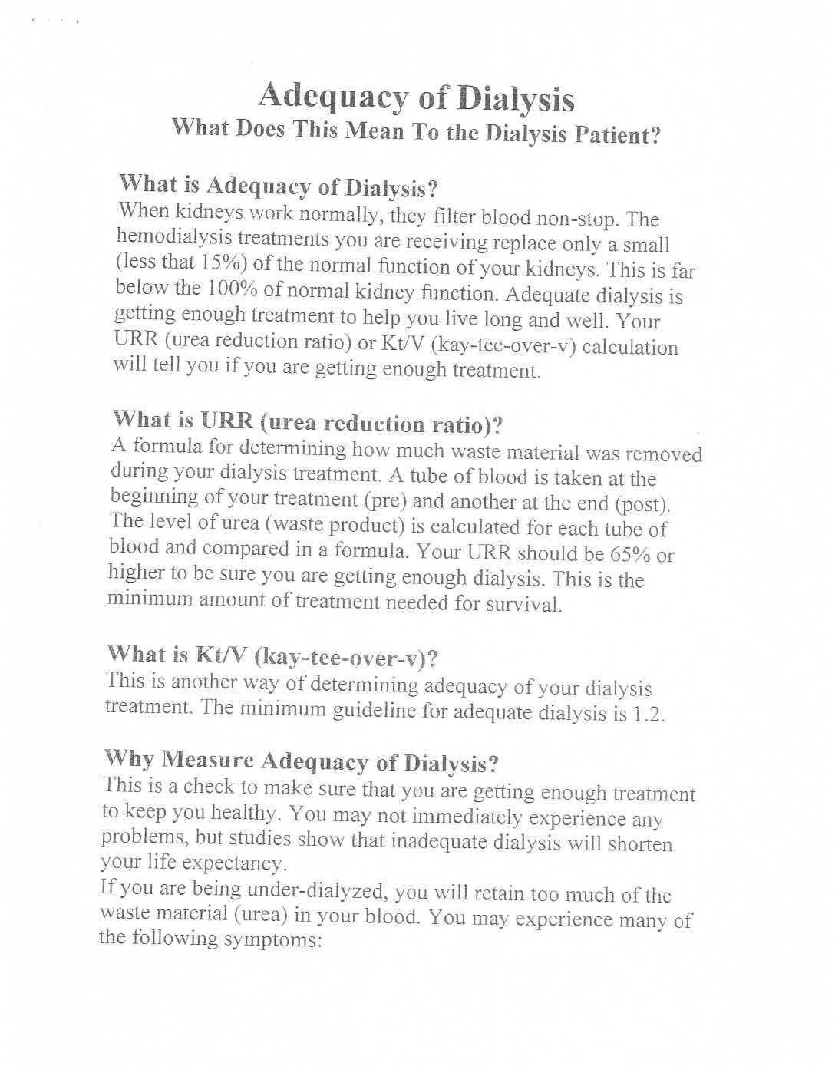
Source: UVA Health System
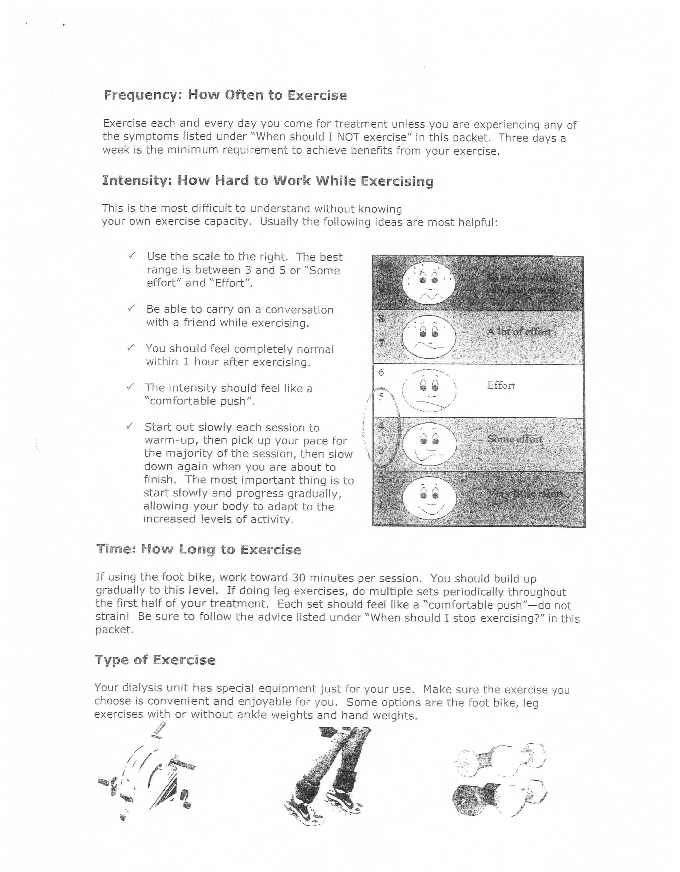

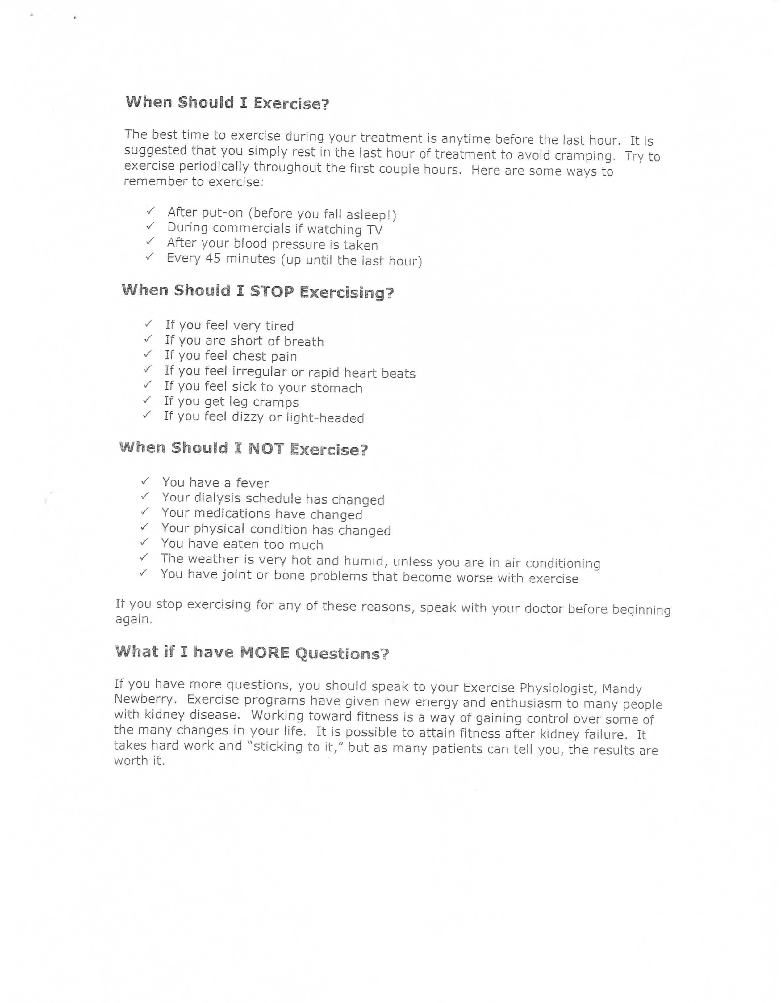
Source: UVA Health System


What If…? Activity

Think about how you would respond if your mentee said
the following...

Mentee says: When my kidneys failed, I really didn’t think about the treatment options that were available. It was a whirlwind and I ended up in-center. I remember hearing
about other options like home dialysis. Do you know
anything about that?

Mentee says: I really have been feeling tired and worn out. My doctor said something about “hema” something-or-other being at 25%, but I didn’t understand. What is that “hema” thing?

Mentee says: I don’t think that I am getting the care that I need here. I ask the techs and nurses for help, but they just ignore me. Also, they never put me on the machine on time. I always end up waiting at least 15 minutes.

Mentee says: I am really worried about my job. I need to keep working, but dialysis has made me miss some work and I think my boss may be thinking of firing me. What can I do?

The American Heritage Stedman's Medical Dictionary, 2002, Houghton Mifflin Company.
American Heritage Dictionary

