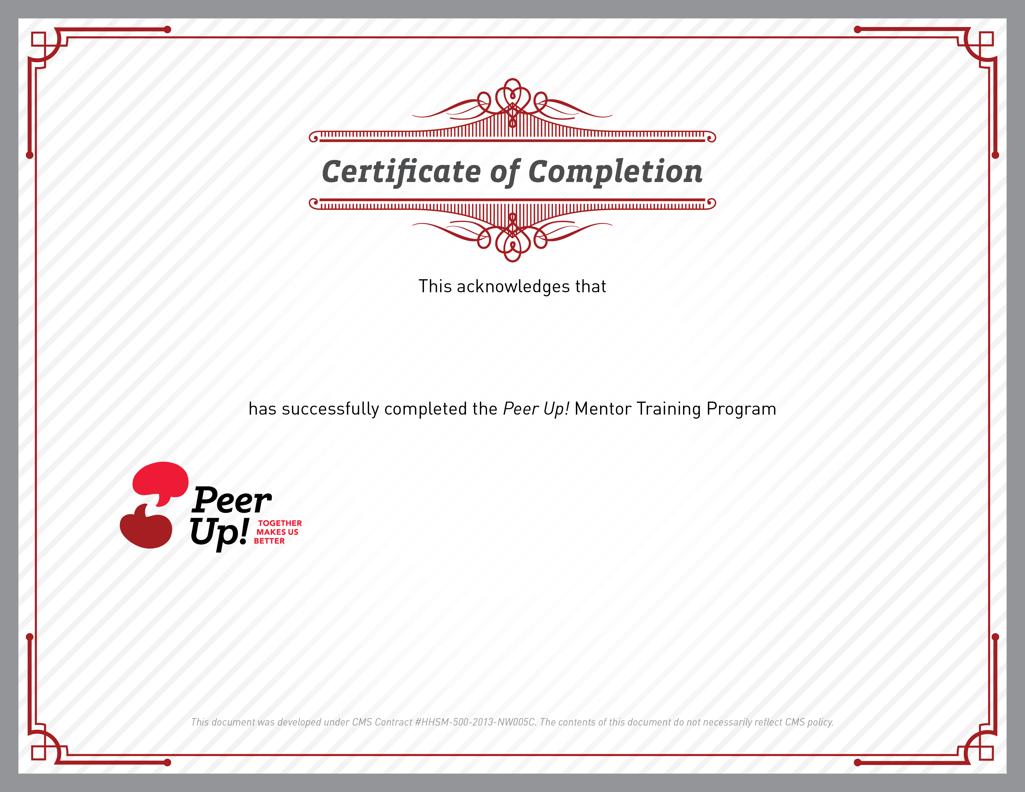
Insert date here
Name Goes Here, Title Goes Here

Mentor Name Here
Insert center logo here

