This guide lays out the planning and implementation steps—including management tasks, resources, and program considerations—needed to successfully implement the Peer Up! program at your facility. Although it does take some staff time and resources to get the Peer Up! program started, once it is launched and trainings are completed, the program will require fewer and fewer resources as time goes on. For example, as more patients participate in the program, they can begin to take on some of the program leadership responsibilities, making the program less time-intensive for staff and more peer-focused.

Program Management Guide

While peer interaction is at the core of the program, you still need to plan and coordinate it to make sure that peer mentors are trained and supported throughout the program period so that they can be of greatest benefit to their mentees.
Please see the box below for a summary of program-management needs. Read through the rest of this guide and toolkit for additional details, tips, and tools.

Peer Up! Program Tasks at a Glance
- Assign a manager to plan the program, adapt materials, and coordinate with staff and participants (see “Staff Roles and Responsibilities” in this guide).
- Promote Peer Up! at the facility to encourage patients to sign up and staff to nominate patients.
- Collect and review applications.
- Train mentors (schedule and conduct training; this may include arranging transportation for participants who may need it to attend the training).
- Match mentees with mentors.
- Host a kick-off mixer(s) for mentors and mentees to meet and to describe program expectations to all participants.
- Provide support to mentors as they meet with their mentees.
- Host a celebration mixer(s) to close the program and recognize program participants.

Deciding to Peer Up!
The Peer Up! program offers your facility a proven way to engage patients in care and increase knowledge, confidence, and social support for living with dialysis—all of which improve their chances of better outcomes. But these aren’t the only benefits of Peer Up! See this toolkit’s “Peer Up! Program Background and Overview” section for more.
“The coolest thing was the day I saw a pair throwing a football out beside the dialysis unit—simple fun for a dialysis [patient]—we don't get to see that often enough.”
University of Virginia (UVA)
Lynchburg Dialysis Staffer
Whoever the source of interest in Peer Up!—be it a staff member who wishes to help patients become more engaged or someone in leadership interested in decreasing the number of missed treatments—it is important that your entire staff become familiar with Peer Up! and how they can get involved. Most importantly, your facility’s leadership team—including the medical director, administrator, and charge nurses—must be invested in the success of the program to ensure that facility resources will be available.

Assigning Staff Roles and Responsibilities
In our experience, the road to program success lies in assigning a single program manager or coordinator to lead Peer Up! efforts. This person will ensure the following:
- All parts of the program are being carried out as intended.
- Leadership is informed and kept up to date.
- Program activities benefit from the involvement of a range of staff.
- Both patients and staff know whom to turn to with questions and concerns.

The following table provides a look at the staff roles and responsibilities.

ROLE | RESPONSIBILITIES
  Peer Up! Program Manager/Coordinator  Think outside the box! A peer-to-peer program doesn’t have to be managed by a social worker. Is there someone in your facility, like a receptionist or administrative assistant, who could lead the project? | - Lead the program.  - Ensure approval of leaders and managers and update them on program progress.  - Assemble and lead a planning committee.  - Plan activities according to a timeline.  - Brief the entire staff on the program.  - Manage contributions from participating staff.  - Conduct or assign additional tasks, such as adapting materials, copying, and printing.  - Check in regularly with mentees and mentors.
Floor Staff | - Promote the program to patients.  - Answer basic questions about benefits of participation.  - Nominate patients.  - Provide feedback to program manager about pairings.  - Direct medical questions to charge nurse.  - Check in with participants to see how things are going with their mentee/mentor and alert the program manager of any issues.
Charge Nurse(s) | - Know the program.  - Promote the program to patients.  - Answer basic questions about benefits of participation.  - Nominate patients.  - Provide input on training and educational materials for mentors.  - Assist with the development of an emergency program protocol.  - Be responsive to all mentors in emergencies, as well as for routine questions and concerns.
Dietitian(s) | - Know the program.  - Promote the program to patients.  - Answer basic questions about benefits of participation.  - Nominate patients.  - Provide input on training and educational materials for mentors.  - Provide guidance on menus for mentor training and mixers.

ROLE | RESPONSIBILITIES
Social Worker(s) | - Know the program.  - Promote the program to patients.  - Answer basic questions about benefits of participation.  - Nominate patients.  - Provide feedback to program manager about pairings.  - Help peers if counseling is needed, such as if a peer dies during the program.
Trainer | - Review the Mentor Training Manual and adapt activities according to facility needs.  - Lead a training that fits participant needs (e.g., 1-day, 2-day, or chairside).  Note: If a trainer is not available, this responsibility could be shared across various staff and eventually experienced mentors, too.
Data Manager/Evaluator | - Develop and implement a plan for assessing the success of the program.  - Adapt assessment and evaluation tools to meet facility needs.  - Collect and analyze Contact Logs, surveys, and other information from mentors and mentees (to assess how the program is changing knowledge, self-efficacy, and self-care behaviors).  Note: If an evaluator is not available at your facility, consider working on the evaluation with a local college or university.

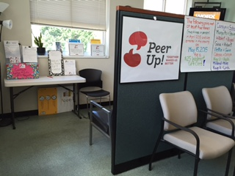
Logistical Needs
Peer Up! meeting space in UVA Lynchburg Dialysis waiting area
The following might also be needed:

- A consultation room, sheltered desk area, or other space where peers can meet without fear of being overheard by other patients
- Space for kick-off mixer(s) and celebration mixer(s) (e.g., a conference room)
- Renal-friendly snacks and beverages to share at the mentor training, kick-off and celebration mixers, and other social events
- Approved educational materials (e.g., fluid and diet tip sheets) that support patient needs
- Training resources (e.g., conference room, flipchart, and markers; see the Mentor Training Manual for more detail)
- Printing and copying of brochures, postcards, and handouts
- Give-aways (e.g., coupons, gift cards, water bottles, or other items to use
as incentives for program participation, which local businesses may be willing
to donate)

Planning and Tailoring the Program to Your Facility
Once you have buy-in from your leadership team and key staff, use this toolkit to plan your program. Read through the materials in each section and use the planning checklist to guide the implementation of the program and to ensure that all steps and tasks are covered.
One key first step is to adapt Peer Up! to the specific needs of your facility. Consider the following program elements and related questions as you make your plan:
- Timeframe. When should you launch your program and how long should it run? Peer Up! is designed to be a time-limited program; that is, peer mentors and mentees meet regularly for a particular length of time. Once it is implemented, the program can be repeated again with new participants. The Peer Up! pilot ran for four months so that peers could meet in person approximately eight times. This allowed enough time for pairs to get to know one another and to build relationships without requiring a strong commitment beyond the scope of the program. In addition, think about what time of year may work best. The Peer Up! pilot launched in winter, which caused some weather-related delays and travel challenges.

- Number of Participants. The recruitment brochure in the Peer Up! Program Toolkit was developed to build a sense of excitement and urgency among participants by presenting the program as a limited opportunity. This allows you to invite a limited number of patients to participate and to keep interest high by asking others to wait until the next program cycle. Plan to recruit 5–10 pairs, which is small enough to create a sense of community yet allows for a bit of attrition. The Peer Up! pilot—which was held in a facility with approximately 250 in-center patients—enrolled 23 pairs, and 21 pairs finished the 4-month program. Ultimately, the number of patients you choose to recruit as mentors and mentees will depend on a number of factors including the size of your facility (i.e., your pool of participants), how many new patients may require additional support, and how many peer pairs your staff can feasibly support. Once the program has been active for a while, you might consider requiring that any patient that wants to serve as a mentor must have first participated as a mentee. This will create program sustainability and invested patients over time.
Consider inviting all new patients to participate in Peer Up!

- Policies and Procedures. Review the entire program with an eye to your facility’s existing policies and procedures; consider creating a basic policy that addresses the following:
- The effects of patients meeting outside of treatment time on patient flow and waiting areas
- Who must be informed in case of emergency or if a program participant has a medical need
- How to inform program participants about schedule changes, weather delays, or the death of a peer
- Whether peers can complete Contact Logs and feedback forms under your privacy policies.

- Peer Up! Activities. You can find instructions and materials for all program activities in this toolkit. Each activity—from promotion and recruitment to program closing—can be tailored and adapted to the needs of your staff, facility, and patients. One way to make sure that program activities meet your specific needs is to task the staff person in charge of a particular activity with reviewing the corresponding section of the toolkit. Consider engaging a patient advisor or patient advisory committee in the process.

- Peer Up! Materials. As you plan your program, review the mentor and mentee materials in this toolkit and revise them as needed. Most materials are available in Word format, for easy editing and branding (i.e., insertion of your facility logo and contact information). Many are also available in large type size for visually impaired participants.

Kicking Off and Promoting Peer Up!
Peer Up! can only work if patients at your facility know about it and want to participate. Once your program plan is in place, you can draw on a number of promotional materials in this toolkit to “advertise” your program to potential participants as well as staff. To get the word out, you can distribute postcards, brochures, and applications to patients. Consider posting announcements about the program on bulletin boards, lobby monitors, and through electronic media (e.g., Facebook page, listservs, Twitter) and patient newsletters.

Tips for Mixers
Check in with your planning committee before each mixer to make sure everyone knows their role, all materials are secured, and food is ordered.
Consider distributing restaurant gift cards to pairs as door prizes or raffle drawings. These encourage meetings and social interactions outside the facility.

One way to launch the program is to hold a kick-off mixer(s). The Peer Up! pilot at UVA Lynchburg Dialysis held kick-off mixers for all program participants in the conference room at the facility. Four different mixers were held to accommodate participants’ schedules. For the kick-off, make sure to schedule several minutes for staff managing the program to present program expectations; describe how the program will be carried out; and remind participants about confidentiality, completing Contact Logs, and the use of available educational materials, as appropriate. A final celebration mixer was held at the end of the program at a local restaurant.
Be sure that your management team and staff are on board and ready to answer questions before announcing the program to patients and during the kick-off and other events.

Pairing Mentors and Mentees
The application is designed to gather the information needed to match mentors with mentees. First, review the applications to ensure that the patients who requested the role of mentor are appropriate. You can find selection criteria in Tips, Strategies, and Talking Points for Recruitment and Retention in this toolkit.

Should you have applicants who are not appropriate, meet with them one on one to gently explain the reason why they are not a good fit for the program. For instance, someone may not have had enough time at the facility or have not been on dialysis long enough to be a mentor. If possible, encourage this individual to participate as a mentee. Others may be medically fragile. You may wish to recruit a few more mentors than your program needs, in case they don’t complete the training or may not be appropriate or qualified following the training.
Similarly, check the mentee applications to ensure that they are patients who will benefit the most from Peer Up! at your facility. Among those who could benefit most are new patients, patients struggling with self-care, or those with few social supports. Please remember that Peer Up! is not designed to address depression or provide other mental-health support.
Use the application forms to match mentors and mentees based on their answers to questions. In the Peer Up! pilot, the most important matching criteria were treatment schedule, transportation challenges, and age. Once initial matches were made using these criteria, other variables such as hobbies and household composition (e.g., family members and pets) were considered. You can use a simple spreadsheet or handwritten chart to keep track of your matched pairs and their characteristics. Once everyone is matched, you may wish to share the list with a few floor staff and a social worker who know the patients well so that they can offer further insight.
You can use the sample letters in this toolkit to welcome participants to the program. If possible, introduce the pairs at a kick-off mixer (see section above). If holding a mixer or kick-off event is not possible, introducing pairs individually will work, too. The important thing is getting the program started in your facility in a way that works best for you and your patients.
For all participants, be sure to spend some time explaining privacy and confidentiality. You may wish to ask each participant to sign a confidentiality agreement (see sample in this toolkit). Mentors and mentees must not discuss with others—even family or friends—the information shared during their interactions.

Providing Mentor and Mentee Support
The mentor training and Guide for Mentors provide the skills and information mentors need to be effective in guiding mentees; however, additional needs may arise. Review Tips and Strategies for Pair Management in this toolkit for ways to meet these needs and provide ongoing support to the pairs. As you track their progress, you may wish to consider holding a booster training for mentors to address topics or issues that keep coming up or to help mentors practice additional communication and support skills. A sample booster training can be found in the “Mentor Training Manual.”
As you check in with peer pairs, stay aware of potential communication or relationship-building challenges. There may be times when pairs need to be dissolved and participants re-assigned. You can find guidance on this and other events that could affect peer-pair interaction, such as hospitalizations and death, in Tips and Strategies for Pair Management.
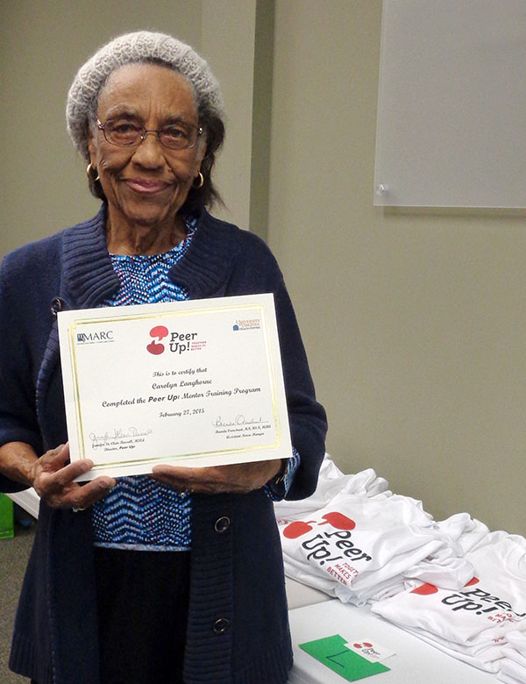
As part of the planning process, your team should have developed clear procedures to be followed in the event of an emergency (such as an acute illness or other medical concern) during a peer session. Be sure to communicate these procedures regularly with all participants, including during mixers, chairside check-ins, and booster trainings. Remind staff during staff and/or patient case-management meetings.
Peer Up! participants received certificates
of completion after completing the mentor training
A celebration mixer, as suggested previously, can also serve to support mentors and mentees if you recognize and applaud their participation in the program and celebrate the program’s success.

Sustaining the Program
This toolkit contains a section on how to evaluate the success of your program using participant feedback and how to capture psychosocial health outcomes, such as self-efficacy and knowledge. If you decide to evaluate your program, be sure to analyze the data you collect and share your successes with your facility’s leadership team so that they recognize the value of the Peer Up! program. In addition, you may wish to report some of the measures and successes to your ESRD Network or any funders/supporters of the program. Always be sure to share the results with the patients that participated in the program as well.
There is no limit to the number of times you can run Peer Up! to reach and help new patients. How often you do so will depend on the size of your facility and your available resources; however, you may wish to consider implementing it once a year for greater continuity.

